

The Hookup application on your handset lets you talk, chat and connect on the move anywhere, anytime with hookup registered friends from your contact list. As Hookup uses the Internet for sending/receiving SMS, your messaging is almost free of cost. Read on to explore more cool features of Hookup.

**Whats Cool..**

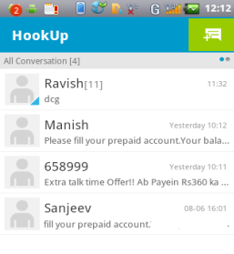

* Send and receive instant messages. Presents conversation

in IM bubble, sorted by time.

* **Start group chat with friends**
* Share images, photos, voice, sketches, contacts and location.
* **Emoticons**: Hookup offers you lots of emoticons to enliven and make your communication expressive.

**Requirements**

To enjoy the features of Hookup, all you need are:

* Internet connectivity on your SIM
* Registration with hookup for you and your friends
* SD card for sharing your files with friends

For information on Setting up Internet connection on your phone, refer to the User Guide.

**Registration**

1. Before registering for Hookup, ensure that SIM Card is inserted in SIM 1 slot, and Wi-Fi is Disabled or not connected.

2. Insert SIM card and memory card into the handset.

3. Power on the handset and tap Hookup.

4. Tap > **More > Activate**. Your Hookup will be activated and ready for messaging.



**Note:**

Hookup allows you to record and send audio clips of up to 60 seconds.

Hookup allows message communications of up to 512 characters or less in 1 SMS.

**Start Using Hookup**

* Tap Hookup on the main screen.

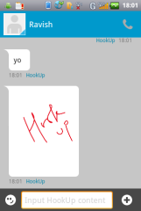

* Tap on to send messages to any contact.



* Tap on a contact to chat with friends.
* Tap to initiate group chatting, view contacts, search   
  and so on.



* Tap > **More** to set your hookup status and desired preferences.



* Tap on to share snapshots, images, audio, doodle (sketches), location and contacts.



* Tap to revert.



Note: Hookup users will be tagged with a blue mark for easy identification.

**Share Your Captured Moments**

* Tap Hookup on the main screen.

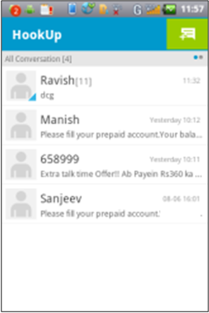

* Tap on to share snapshots, images, audio, doodle (sketches), location and contacts with Hookup friends.



* Tap on:
* to share your location with friends



* to share contacts



* to capture and share snapshots



* to share images



* to record and share audio



* to Doodle(create your desired freehand sketches) and share with friends



You can use the free SMS by tapping Options> More> and enable Send SMS to offline friends.

**Set Hookup Preferences**

You are free to set your various hookup status and preferences as per your changing requirements.

* Start Hookup

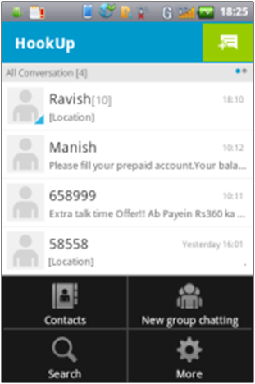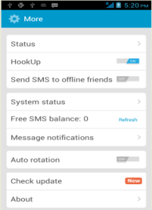

* Tap > **More** to set your hookup preferences.

**Update Hookup**

You can update your Hookup to the latest available version on the net by tapping **Options > Mode> Enable “Check Update”.**

**Product Support**

* **Helpline Number**: 011-44770044

**Working Hours**: Monday to Saturday 10:00 AM to 6:30 PM (Except National & Public holidays)

* **Email Support**: [service.superfone@micromaxinfo.com](mailto:Service.superfone@micromaxinfo.com).

For more information, please visit our website www.micromaxinfo.com.

