Welcome
You have now become the owner of the A116. This phone offers you the versatility of Android coupled with the trusted craftsmanship of Micromax. Get ready to enjoy the joyride
- Android 4.1.2
- 1.2GHz Quad Core Processor
- Dual SIM support
- 8 MP Rear Camera
- Pinch Zoom Feature
- 5 Inch Capacitive Touch screen
- HSDPA
- HSUPA
- GPS
- Bluetooth
- Memory Card Support
- Voice Search

Phone Layout
The following figure shows the phone layout along with the keys and parts for your reference.
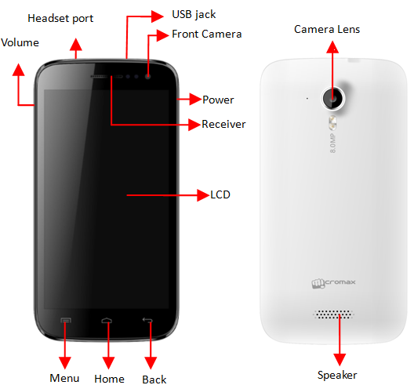

Getting Started

Insert SIM Card
- Switch off the mobile phone and remove the rear cover and battery.
- Insert the SIM card(s) correctly in the card slot(s) as shown below.
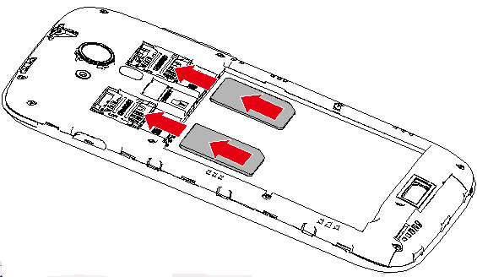
- Finally, insert the battery and place back the rear cover of the mobile phone.

Insert Memory Card
- Switch off the mobile phone and remove the rear cover and battery.
- Insert the memory card into the slot as shown in the diagram:
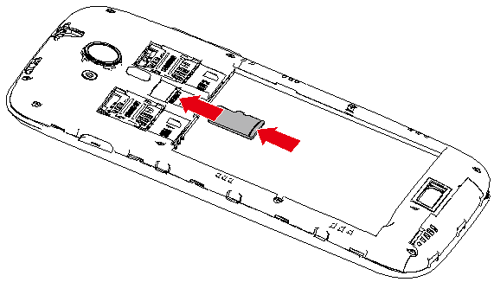

Note: Use only compatible memory cards approved by Micromax with this device. Incompatible cards may damage the card and the device and corrupt data stored on the card.

Using the Touch Screen
Please refer to the preceding phone layout for a better understanding:
You can use the touch screen in the following ways:
Action | Effect
Touch | Acts on items on the screen, such as application and settings icons, to type letters and symbols using the onscreen keyboard, or to press onscreen buttons
Touch and hold | Touch and hold an item on the screen until an action occurs
Drag | Touch and hold an item and move your finger on the screen until you reach the target position
Swipe or slide | Quickly slide your finger across the surface of the screen, (without dragging an item). For example, slide the screen up or down to scroll a list
Double-tap | Tap quickly twice on a webpage, map, or other screen to zoom. For example, double-tap a section of a webpage in Browser to zoom that section to fit the width of the screen. You can also double-tap to control the zoom in Maps, and in other applications.
Pinch | In some applications you can zoom in and out by placing two fingers on the screen at once and pinching them together (to zoom out) or spreading them apart (to zoom in).
Rotate the screen | On most screens, the orientation of the screen changes as you rotate it. You can turn this feature on and off

Customize Home Screen
You can add applications, shortcuts, widgets, and other items to any part of the Home screen or change the wallpaper.
- Enter Launcher, long press and hold an application till the screen vibrates, and then release your finger hold.
- Long press and hold the widget or icon you want to move. Once the device vibrates, don't release your hold on the icon. Drag the widget or icon to a new location on the screen.

Manage Notifications
Your notification icons inform you of new messages and events.
When you receive a notification, its icon appears in the status bar, along with a summary that appears only briefly.
Drag the status bar down from the top of the screen as shown below.
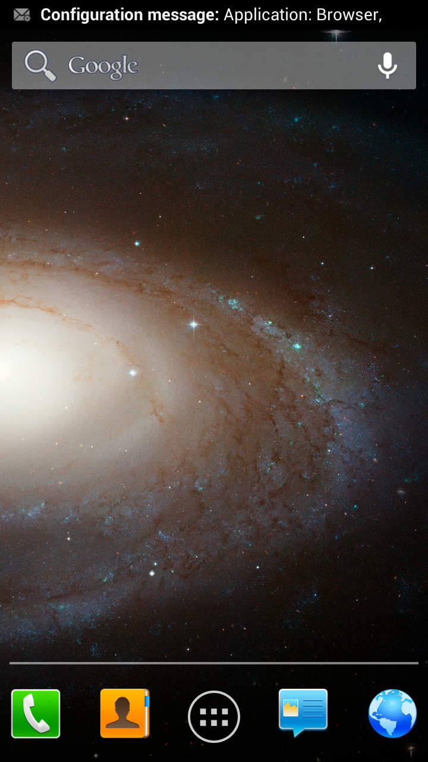— 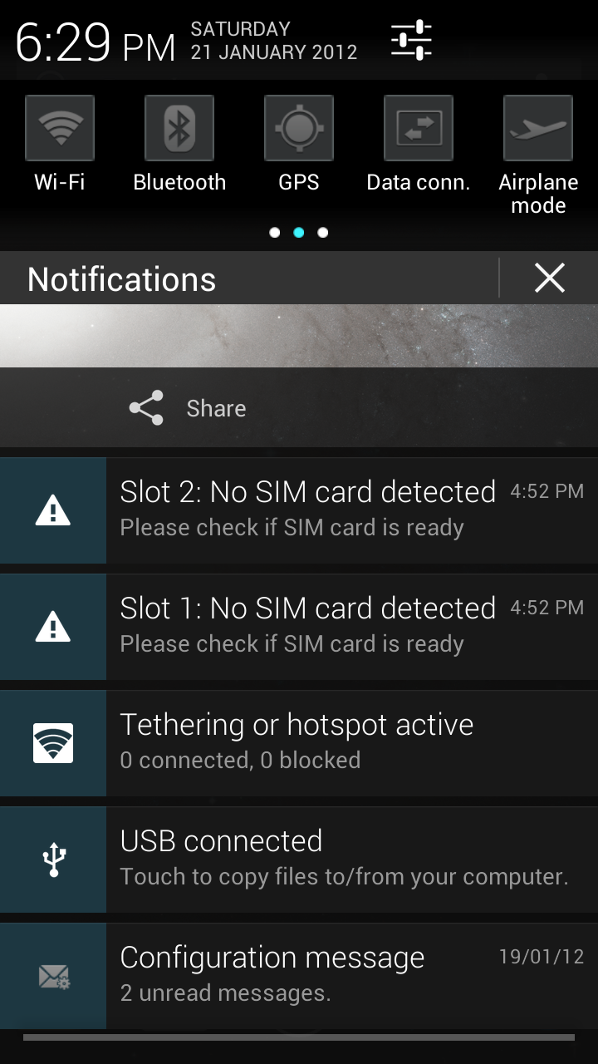
The Notifications panel displays your network provider name and a list of your current notifications.
Drag the tab at the bottom of the Notifications panel to the top of the screen. Or just press the back button. The panel also closes when you touch a notification to respond to it.

Toolkits
Slide the home-screen to view Toolkits and to access and choose various tools available on your handset.
Turn on/off Airplane Mode
Turn on/off Wi-Fi
Turn on/off Bluetooth
Turn on/off GPS
Turn on/off Data Connection

Using Your Phone
Switch On/Off
- To switch on your device, press and hold the Power key.
- In standby mode, press and hold the Power key to open phone options. Next, press the Power off option that appears on the display.
- In the same way, you can reboot your phone.
Unlock the Phone
You can lock the phone using Pattern lock, PIN, Password or Slide lock.
To unlock the phone, do one of the following:
- Press and hold the Power key. The LCD shows up with a lock.
- Slide the lock to with your finger to unlock the phone.
If the phone lock has been activated, you need to enter the password to unlock.
Make a Call
- Touch the icon to enter your desired number and press the/ icon on the dialer pad that displays.
OR
- Touch the icon and press the icon to access the desired number. Tap on the number to make the call.
Answer/Reject a Call
- To answer a call, slide the phone icon to the right.
- To reject a call, slide the phone icon to the left.
Make an International Call
- In dialing mode, press and hold the 0 key, until the + sign appears on the screen.
- Enter the desired international code and then the complete phone number and make the call.
In Call Options
- Touch the icon to add another person to the call.
- Touch the icon to mute your voice so that the phone’s MIC will not transmit voice to the other end. You can resume transmitting your voice by pressing the icon again.
- During a conference call, press the icon to split the calls.
- When a call is active and another is on hold, then tap the icon to merge the calls.
- Touch the icon to listen via the speaker.
- End the call by pressing the icon.
Configure 3G Connection
You do not need to configure your 3G connection. When you obtain a 3G enabled SIM from your service provider, your A116 automatically latches on to the network allowing you to enjoy the features of 3G. You can also activate 3G on your existing SIM. For this it is advised to contact your service provider.
Change Screen Display Orientation
You can change the orientation of your screen by rotating the phone in landscape or portrait view.
Listen to Music
Menu > Music
You will be presented with the list of available songs to play. You can listen to music by tapping the required icons.
Send Messages
Menu > Messaging
You can compose a new message or reply to existing messages in the list.
Add Contacts to Phonebook
Menu > Dialpad
- Dial a number and click on .
- You can either create a new contact or can add the number to existing contacts.
Browse the Internet
- Go to Browser.
- Enter the web address and click ‘Go’.
Note: To browse the Internet, your Internet settings need to be configured first. You can refer to the Frequently Asked Questions section of the User Guide.
Transfer Data via USB
- Connect the phone with the PC/laptop using the USB cable supplied with this device.
- Drag the notification header downwards (on the top portion of the LCD, tap and drag down your finger).
- Tap USB Connected > Turn on USB Storage.
The file dialog will open on your PC for file transfer between the PC and Phone.
Using my A116 as a Modem for Internet Connectivity
You can use your A116 as a modem and connect your PC or laptop to the Internet when required. You can do this via:
- USB Tethering
- Wi-Fi Hotspot
Connectivity via USB Tethering
You need to insert a data service enabled SIM card in your phone.
- Connect your A116 to your computer through the USB cable.
- Go to Settings> Wireless & networks> More>Tethering & portable hotspot > USB Tethering.
The driver installation window will pop up on your PC or laptop.
- Install the driver as suggested.
You can now start using the Internet service via your A116.
Note: Your mobile operator will charge you based on your GPRS data usage.

Connectivity via Wi-Fi Hotspot
You need to insert a data service enabled SIM card on your phone to use your A116 as a router.
- Go to Settings> Wireless & networks>More>Tethering & Portable hotspot> Wi-Fi Hotspot.
- Configure your Wi-Fi hotspot as suggested.
Make sure your computer has Wi-Fi. After connecting to the Wireless network, you can use the GPRS service from your A116.
Note: Your mobile operator will charge you based on your GPRS data usage.

Other Notable Features
Capture Photos and Videos
Menu > Camera
Use the slider that displays to shift between camera and video mode.
Features:
- 8 Megapixel Rear Camera with 4x Zoom (Camera mode)
- White Balance/ Color Effect/ Scene Mode
Use Voice Command
Menu > Voice Search
Use voice commands to access various useful features on your A116 .
- Tap on icon.
- Issue your desired voice command to the phone.
Use the Pinch Zoom Feature
You can open any image or web page and then use your thumb and index finger to zoom the display through the pinch gesture as illustrated below.
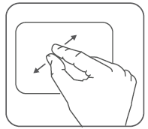
Synchronize Contacts List
Settings> Accounts>Add Account
- You can either add a new account or can use existing account.
- Enter your Email ID and Password and tap Next.
- Enter/edit the domain/username and server if required for corporate account.
Choose the account options that display and tap Next.
- Follow the suggested steps.
Your contacts synchronization will be complete in a few seconds.
To auto-sync an existing account:
- Tap on an existing account.
- Tap Sync Contacts. (All phone contacts will be copied to that email account with details).
For this feature to work, you need to have Internet connectivity via your SIM or Wi-Fi. If your Sync does not proceed as expected, check whether data option is set to ON.
Record Sound
Menu > Sound recorder
Tap the icon to start recording. Tap the icon to stop the recording.

Safety Precautions
Please read these simple guidelines. Not following them may be dangerous or illegal.
Safe Driving
- Do not use the phone while driving. When you have to use the phone, please use the personal hands-free kit.
- Please do not put the phone onto any passenger seat or any place from which it may fall down in case of vehicular collision or emergency braking.
During Flight
Flight is influenced by interference caused by the phone. It is illegal to use a phone on the airplane. Please turn off your phone during a flight.
In Hospitals
- Your Phone’s radio waves may interfere with the functioning of inadequately shielded medical devices. Consult a physician or the manufacturer of the medical device to determine whether they are adequately shielded from external Radio Frequency. Switch off your device when regulations posted instruct you to do so.
- To avoid potential interference with implanted medical devices such as a pacemaker or cardioverter defibrillator:
- Always keep your phone at least 15.3 centimeters (6 inches) from the medical device.
- Do not carry the wireless device in a breast pocket.
- Turn off the phone if there is any reason to suspect that interference is taking place.
- Follow the manufacturer directions for the implanted medical device.
- If you have any questions about using your wireless device with an implanted medical device, consult your health care provider.
Unsafe Areas
Please turn off your phone when you are close to a gas station or in the vicinity of any place where fuel and chemical preparations, or any other dangerous goods are stored.

Taking Care of Your Device

Your device is a product of superior design and craftsmanship and should be handled with care: The following suggestions will help you protect your phone:
- Keep the device dry. Precipitation, humidity, and all types of liquids or moisture can contain minerals that will rust electronic circuits. If your device does get wet, remove the battery without turning on the device, wipe it with a dry cloth and take it the service center.
- Do not store the device in high or cold temperature. High temperatures can shorten the life of electronic devices and damage batteries.
- Do not use or store the device in dusty, dirty areas. Its moving parts and electronic components can be damaged.
- Do not attempt to open the device other than as instructed in this guide. Repairing this phone by yourself other than our authorized service agents/centers goes against the warranty rules.
- Do not drop, knock, or shake the device. Rough handling can break internal circuit boards and fine mechanics.
- Do not use harsh chemicals, cleaning solvents, or strong detergents to clean the device. Only use a soft, clean, dry cloth to clean the surface of the device.
- Do not store your device near magnetic fields or allow your device to come in contact with magnetic fields for extended period of time.
- Location: The socket-outlet shall be installed near the equipment and shall be easily accessible.

Battery Recommendations

- Please put the battery in a cool and well-ventilated place out of direct sunlight. We recommend you to charge the battery at room temperature range.
- Batteries have life cycles. If the time that the battery powers equipment becomes much shorter than usual, the battery life is at an end. Replace the battery with a new battery of the same make and specification.
- Use manufacturer approved batteries, chargers, accessories and supplies. Micromax will not be held responsible for user’s safety when using unapproved accessories or supplies.
- Do not discard the battery with household trash. Please dispose of used battery according to your local environmental laws and guidelines.
- Warnings on Battery:
(a) Please use appointed battery in case of explosion risk.
(b) Please dispose of lifeless battery under guidance.

Recycle Your Phone
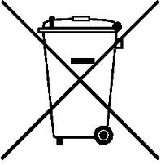 The WEEE logo (shown at the left) appears on the product (battery, handset, and charger) to indicate that this product must not be disposed off or dumped with your other household wastes. You are liable to dispose of all your electronic or electrical waste equipment by relocating over to the specified collection point for recycling. of such hazardous waste.
Collection and proper recovery of your electronic waste equipments at the time of disposal will allow us to help preserve the environment. Recycling of the electronic waste equipment will ensure safety of human health and environment. For more information on best practices for disposal of electronic and electrical waste, please visit to our web site: www.micromaxinfo.com/weee.php

Disclaimers
- The colors and specifications shown/mentioned in the user manual may differ from the actual product. Images shown are for representation purpose only. Other product logos and company names mentioned herein may be trademarks or trade names of their respective owners.
- Micromax keeps the right to make modifications to the content in this user guide without any prior notice.
- The functions explained or listed in this manual may differ from the actual functions appearing in the mobile phone. In such a case, the latter shall govern. We do not guarantee the absolute accuracy of the User Guide Vis-a vis the actual handset.
Copyrights
All rights reserved. Reproduction, transfer, distribution or storage of part or all of the contents in this document in any form without the prior written permission of Micromax is strictly prohibited.

